**PROGRAM NO :3**

**AIM:** Implementing basic arithmetic operations of a simple calculator.

**PROGRAM CODE:**

|  |  |
| --- | --- |
| Mainactivity.java | **package com.example.calculator;**  **import androidx.appcompat.app.AppCompatActivity; import android.os.Bundle;**  **import android.view.View; import android.widget.EditText;**  **public class MainActivity extends AppCompatActivity { EditText num1,num2,result;**  **int n1,n2; String s1,s2,s3; @Override**  **protected void onCreate(Bundle savedInstanceState) { super.onCreate(savedInstanceState); setContentView(R.layout.activity_main);**  **}**  **public void getNum()**  **{**  **num1 = (EditText) findViewById(R.id.fn); num2 = (EditText) findViewById(R.id.sn); result = (EditText) findViewById(R.id.res); s1 = num1.getText().toString();**  **s2 = num2.getText().toString();**  **}**  **public void sum(View v)**  **{**  **getNum();**  **n1 = Integer.parseInt(s1); n2 = Integer.parseInt(s2); s3 = String.valueOf(n1+n2); result.setText(s3);**  **}**  **public void sub(View v)**  **{**  **getNum();**  **n1 = Integer.parseInt(s1); n2 = Integer.parseInt(s2); s3 = String.valueOf(n1-n2); result.setText(s3);**  **}**  **public void mul(View v)**  **{**  **getNum();**  **n1 = Integer.parseInt(s1);** |

**};**

**n2 = Integer.parseInt(s2);**

**s3 = String.valueOf(n1*n2); result.setText(s3);**

**}**

**public void div(View v)**

**{**

**getNum();**

**n1 = Integer.parseInt(s1); n2 = Integer.parseInt(s2); s3 = String.valueOf(n1/n2); result.setText(s3);**

**}**

**OUTPUT:**

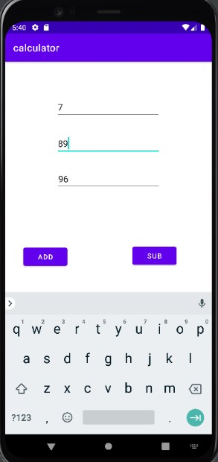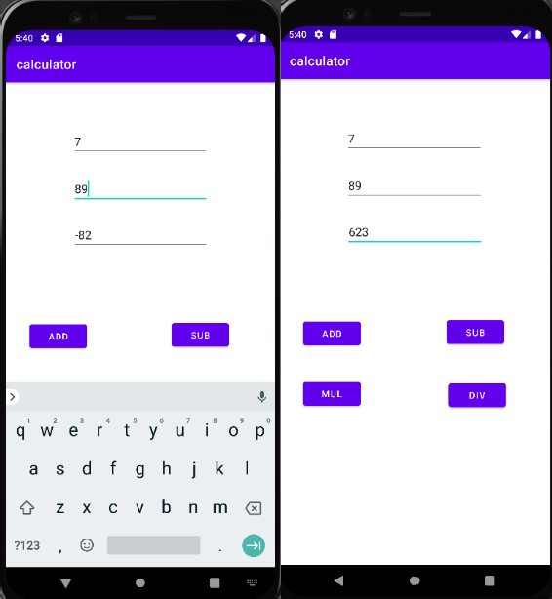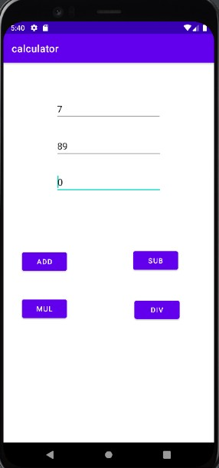

RESULT

Program Has Been Succesfully Executed And Output Is Obtained.